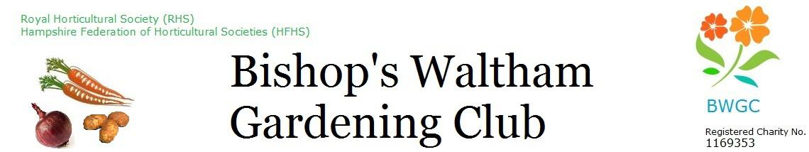
Minutes

Date: Monday 15 September 2025 at The Shed
Time: 7:30 pm

Present: Maewyn Cumming (MC), Linda Haysom (LH), Ron Haysom (RH), Gill Hamill (GH), Robin Breach (RB), Kate Cassell (KC), Neal Davies (ND), Gill Williams (GW), David Bushby (DB), Alison Perry (AP)

Item | Minutes | Actions
- Apologies for absence | Dave Bennett,  Larry Mabey
- Minutes of previous meeting | Couple of updates - updated
- Actions list – Outstanding Actions from Aug Meeting | - ALL – Get outstanding invoices to in as we get to end of FY. - ongoing  - ALL – each budget holder to review budget and make decision as to whether need more or less for next year.  - LH investigate alternative banking arrangements  - MC – approach John Price re honorary membership
- Trustee Retention and Attraction/Chair | DCB handed in resignation as chair and trustee – thanks go to Dave for his time and his contribution over the past years. This is a huge loss to the club. Dave was part of the team that was able to get the site fenced and gated which is a fabulous achievement and all allotment holders will benefit from this. Dave also created a positive working relationship with the parish council that the remaining trustees hope to be able to maintain.  Few names put forward as potential trustees – these to be contacted by the appropriate trustees.  RH and GH gave prior warning of their resignation at the next AGM.  MC will act as meeting chair until this post is replaced.  Need trustee on the Finance Subcommittee and for social media. | - AP to update charity commission  - RB – to add chair advert to parish news  - MC – to put request out on BW chatroom
- Trustee roles and responsibilities | Trustees looked at the list of roles both DCB and AM undertook (outside of their main trustee role). These were divided amongst the other trustees. See separate document.
- Finance | See LH’s finance papers.  £27251.59 total in bank  LH looking for better interest rates,  Likely to breakeven by end of year (Sept 30)  Thanks to everyone for their budget statements  Lloyds will soon start charging a monthly fee so LH will investigate alternative banking arrangements.  Invoiced Cricket Club for water and this has been paid  Lloyds - £60 credit.  Trustees have pulled together plans for improvements to the site. These need to be costed and quotes received in time for the AGM so members can be updated and to show how the money is being spent. | - All – obtain quotes for improvement works as discussed.
- Membership | We have 378 members, including 178 plot holders. Numbers are steadily increasing.  Shop voucher scheme to go out – what to do was discussed at previous meeting.  Membership renewals going out 25/09/25  No cash for membership – either BACS/Card, MC/LH to be at shop to take membership money. | - LM to sort out extra staff at shop – extra trustee (LH, MC),
- Trading | onion sets/garlic in for next year will soon arrive.  Shop vouchers going out need to make sure stock enough for people wanting to spend their vouchers | - LM to ensure sufficient stock
- Allotments | 12/13 on waiting list plus extra areas for people.  Awaiting 3 people to get back but currently no response. DB to follow process of evicting if no response.
- Allotments - maintenance | KC - Payback to come to do some tidying and hedge cutting. Still chasing the PC about trees, and hedge bottom and middle,  Nothing on drainage/shingle  No sign of any deer.  Gates – issues with hanging posts – need to keep an eye on these | - MC to add to email that we have woodchip.
- Allotments - other | n/a
- Monthly programme | November sorted - soils.  Booked 1st half of year (2026) speakers
- Social programme/ Annual Social | GW/LH - Social – 10/10/25 – tickets ready, list if going.  ND – to look at trips for 2026, Wisley as RHS membership is free so just coach trip,  Ideas include: Tuppany Barn, Wreath Making, Cake Making/decorating | - MC - Advertise social – FB/shop, proactive in shop selling.  - MC – email Call for vols to help on evening, 5.30, food ready and laying tables,  - ND – to look at trips for 2026
- Update / publicity / social media | Posters gone out for Parish Council notice boards  Parish news – info out  Newsletter – extra bit for Oct version  FB on going
- Community Orchard/ butterfly garden | See RH update, Helen Fuller to take over butterfly garden – suggested holding a small volunteer event – Orchard/Butterfly garden vols sometime in Oct.  Trustees agreed to spend £20 to tea and cake for the event. | - RH – to do Orchard/Butterfly garden vol event
- Charity programme | St Peters Fayre – Sept, more vols will be appreciated,  Student sponsorship – 2 potentials for coming year, RH/LH to interview,  Greening event, BW Sustainability Oct 11. We will have a stand. Need vols | - MC to send out email for vols for St Peters Fayre/Greening Event.
- Any other business | WhatsApp group – should be used for general discussion for all. If something specific need to message each trustee individually.  If documents to be sent use email/365  Chair Oct Mtg – MC  Shed Check List – opening and closing list of jobs – very helpful, thanks to LH for sorting,  AM – event, 26/10 12pm at Shed,

Meeting finished at 2130

Next meeting: Monday 20 October 2025 at The Shed 7.30pm

